**Practical No 7**

**b. Automate the following screen scraping methods using UIPath**

i. Full Text

ii. Native

iii. OCR

1. Open UiPath Studio and click on Blank to start a fresh project. Give it a meaningful name. Like Pratical.
2. Open Main.xaml from Project tab. On the Designer panel, double click a flowchart activity from the Activities panel.
3. Click on Screen Scraping option from design tab and specify the region from which we need to extract the information.
4. Specify scraping methods as full text and click on finish.
5. Repeat step 3 and 4 by changing methods as Native and OCR.

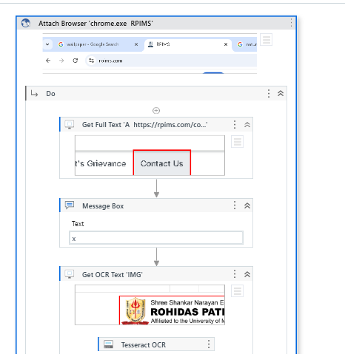

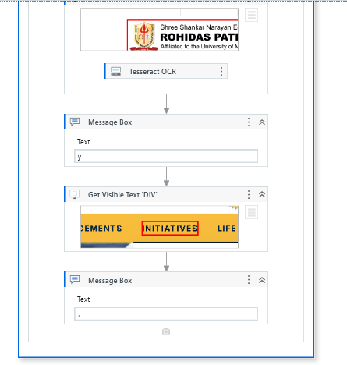

Output:

Native text:

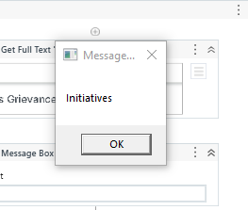

OCR text:

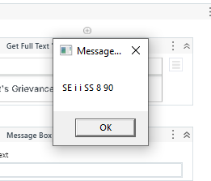

Full text:

